# **AoW—Feminism and Gaming Name:**

|  |
| --- |
| Directions:  𑂂 Annotate the article strategically (that means developing thoughts that you’d be interested in expanding upon in the written reflection).  𑂂 Complete the Reading for Meaning Statements  𑂂 Write a **well-developed** response to the article--on your own sheet of paper. You may choose one of the questions to respond to or choose a question or ideas of your own.  **Guidelines:**   * Clever title properly capitalized. * Summarizes some of the articles main points and arguments **and** responds with questions, opinions, and arguments of your own. * Appropriately leads into, blends, **parenthetically cites**, and discusses **at least** one quote or key fact / statistic from the article. * Explain each quote and discuss your reaction to it (agree or disagree). * Concluding sentences. * 250+ words, NEAT, LEGIBLE, NO DISTRACTING ERRORS. |

**How Will This Be Graded?**

|  |  |
| --- | --- |
| **Reading** | **Writing** |
| |  |  |  | | --- | --- | --- | | **4-5** Strong effort. Mature thinking is obvious. The student makes several margin notes, showing thoughtful interaction with the text. The student circles and defines unknown or challenging words. Margin notes show that the reader is asking questions, identifying main ideas, and connecting to the focus question. Reading for Meaning statements are supported or refuted with relevant evidence. | **3** Adequate effort. The student interacts with the text, but may struggle to dig deep. The student may circle and define unknown or challenging words. Margin notes show that the reader is using some reading strategies to improve comprehension. Reading for Meaning statements are attempted. | **2** Some effort. Interaction with the text is basic. Margin notes are there but do not demonstrate that the reader is thinking deeply about the text. Reading for Meaning statements are not all completed.  **0-1** Little to no effort displayed. Margin notes may not even be there. Reading for Meaning statements are not attempted. | | |  |  |  | | --- | --- | --- | | **5** Outstanding effort. The student obviously proofed this paragraph, focusing on neatness and accuracy. Exceeds all requirements. | **4** Good effort. The product is neat and legible. Meets all requirements.  **3** Adequate effort. The product is legible. Meets most requirements. | **2** Weak effort. The student only completed some of the task.  **0-1** The student completed little to none of the task. |   **Total AoW Grade:**  **______/10** |

**Reading for Meaning Statements**

**Directions:** The purpose of this page is to hone your ability to gather textual evidence to support or refute a statement **and** to focus your reading on some key points in the article. For each statement below, circle whether the text agrees or disagrees with it, and, in the space provided, share quoted, textual evidence to support your agreement or disagreement.

|  |  |  |
| --- | --- | --- |
| **Does the article agree?** | **Statements** | **Evidence from the text (cite page and paragraph; briefly explain)** |
| |  | | --- | | **yes** | | **no** | | 1. The University of Utah was able to increase security at the event because of the threat against Sarkeesian. |  |
| |  | | --- | | **yes** | | **no** | | 2. This event was not the first time Sarkeesian has been threatened. |  |
| |  | | --- | | **yes** | | **no** | | 3. Sarkeesian is demanding that video game developers stop making violent games. |  |

# **One Feminist Critic's Battle With Gaming's Darker Side**

by NPR STAFFPosted: 10/18/14

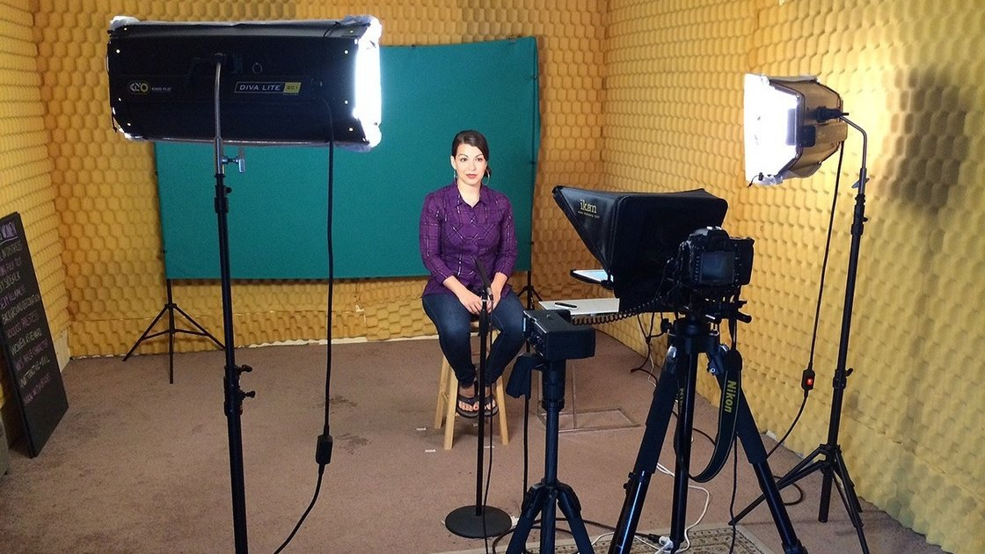

For those who follow the video game industry and its community, feminist critic Anita Sarkeesian is a familiar figure. Her video series "Tropes vs Women in Video Games" analyzes how women are represented in games past and present.

Sarkeesian is also known for the amount of backlash she receives for her criticism. This week, she [canceled a talk at Utah State University](http://www.polygon.com/2014/10/14/6979071/utah-state-university-anita-sarkeesian-threats) after the school received an email that [threatened](http://www.standard.net/Police/2014/10/14/Utah-State-University-student-threatens-act-of-terror-if-feminist.html) a "[Montreal Massacre](http://www.crimelibrary.com/notorious_murders/mass/marc_lepine/index.html) style attack" at her presentation.

Sarkeesian was scheduled to talk on Wednesday and didn't find out about the threats until she landed in Salt Lake City on Tuesday. Tim Vitale, the executive director of public relations and marketing at USU, told NPR that they'd planned extra security and sweeps for explosive devices after they received the threat on Monday. But because of Utah's concealed carry laws, he says, they could not restrict those with permits from carrying a firearm to the event, and that's what ultimately drove Sarkeesian to cancel her talk.

"We still think we had everything in place to ensure a safe environment," he says.

Vitale says he understands Sarkeesian's concerns regarding Utah's gun law in light of the threats against her. But that is a debate yet to be had, he says, and perhaps this incident will "spur that debate to happen more quickly." He says the threat is still under investigation by local law enforcement and the FBI.

The threats against Sarkeesian and other women in the gaming industry are part of a larger ongoing debate about sexism, misogyny and harassment in the video game community. These issues have been running parallel [with the #Gamergate movement](http://www.npr.org/blogs/alltechconsidered/2014/09/24/349835297/-gamergate-controversy-fuels-debate-on-women-and-video-games), an effort that claims to be squarely focused on ethics in video game journalism but often intersects with these incidents of harassment and threats.

This strife in the billion-dollar gaming industry has now vaulted out of the niche gaming press and into the mainstream. The New York Times gave it [front-page treatment](http://www.nytimes.com/2014/10/16/technology/gamergate-women-video-game-threats-anita-sarkeesian.html?ref=video-games&_r=0) after these most recent threats against Sarkeesian. She spoke with NPR's Arun Rath about her history of harassment and why she thinks she, and women like her, are such targets by certain segments of the gaming community.

### Interview Highlights

**On why she canceled her Utah State University appearance**

I eventually got on the phone with the police at Utah State University and they informed me that they would not allow for backpacks and have additional security there. When I asked them about Utah's concealed weapon laws, they informed me that they couldn't do any kind of screening for weapons, which was a little mind-boggling to me, because the threat received was very reminiscent of sort of copycat killers of these misogynist massacres that had been done previously. I was like, 'Can you at least have metal detectors or do pat-downs?' And they refused to do that. So I declined and canceled the event because I felt like that was too high of a risk to put me and the students in.

**On her critique of how women are portrayed in video games**

Sadly, it's actually kind of worse than I thought it was going to be when I initially started this [Tropes vs. Women] project. Often women are framed as helpless or they're prizes to be won or they're highly sexualized male fantasies. The other piece of this too is that there's this enormous amount of violence against women that's used in these games often times as sort of set dressing. Just in the background these women are hurt or beaten up just to make the world seem more gritty. These representations are really harmful to women, and so we're asking for better representations and better stories having more female protagonists that are full and complete characters.

**On her history with harassment**

Since I announced that I was going to be doing a video series specifically looking at the representations of women in video games I have been attacked, and ultimately terrorized, for two years because of this series. Everything from my social media accounts flooded with misogynist and racist slurs to trying to hack into my social media and email. ...

Oftentimes there are very specific rape threats ... that are also connected to my home address or attacks on my parents and my colleagues and their families as well, so they kind of go after everyone in my vicinity. And I'm not the only woman being attacked right now in games. There have been a number of other women who are fearing for their lives and leaving their homes because they're receiving threats as well. So this is actually a larger problem within the gaming community right now.

**On why she thinks this is happening in the gaming community**

In some ways there are some men who have gravitated toward gaming culture because they have been rejected by this larger, alpha male culture. The problem with that is that gaming allows them to fulfill that role — the alpha male role — the macho testosterone posturing you get in a lot of these big, AAA [big-budget] games. So they're actually kind of re-perpetuating that alpha male culture by attacking people that they perceive to be weaker than them. So they're going after women, they're going after queer folks, they're going after trans folks, and especially anyone who speaks up and is critical in any way about gaming.

**Guiding questions for summary of expository article**.

* **What is the main subject of this article?**
* **Explain the subject a little (Who, what, when, where, and or why)**
* **Are there any opinions expressed in this article? If so…**
  + **Who gives their opinion?**
  + **What is their opinion on the subject?**
  + **What reasons or evidence do they have to support their opinion?**
* **Include at least one piece of evidence and explain what it means and why it is important.**
* **Does this article have a purpose beyond just explaining? Is it trying to convince you to change your mind? Change your behavior? Vote a certain way? Other?**
* **Concluding statement**

# ……………………………………………………………………………………………………

**Possible questions for written response (Choose one of these or one of your own. Remember to develop your response into a complete paragraph.)**

* **Do you believe it was the right decision to cancel the event? Should the University have improved security measures based on the threat?**
* **Do you agree with Sarkeesian’s claim that video games often have harmful portrayals of women? Why or why not? If so, what could game developers do differently?**
* **Other questions, observations, or arguments you have related to this piece**